6A^{th} Grade: Unit 7, Lesson 8
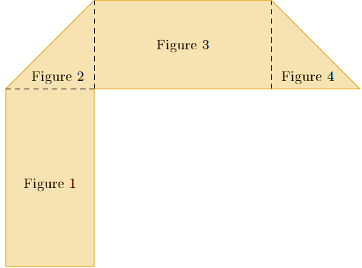
- A decomposed polygon is shown. What formula is needed to calculate the area of the shape Figure 4?

$$\frac{1}{2}·b·h$$

- A polygon is shown. What would be the best way to decompose this polygon?
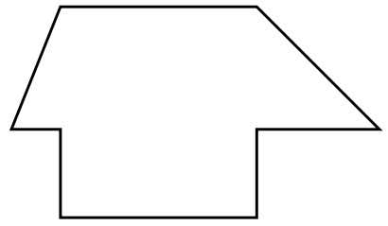

Splitting the polygon into two rectangles and two triangles

- A figure and its decomposition are shown. The polygon was decomposed into 2 triangles and 1 quadrilateral. What do you have to do to find the area of each shape?

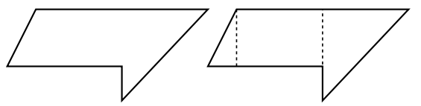

You have to find the area of each shape and add them together

